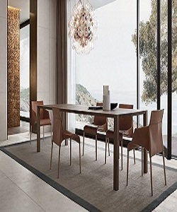

Seattle chair with blade square table

$163.39

Availability: In stock

Description

Luxury and glamour Polifom Dining table. Designed with a lavish modern style, Seattle, design Jean-Marie Massed, is a chair with special light shapes that enhance the exclusive quality of the leather coverings with wood blade square table. Available in different size.